Given an integer n, return *the number of structurally unique****BST'****s (binary search trees) which has exactly*n*nodes of unique values from* 1 *to* n.

**Example 1:**

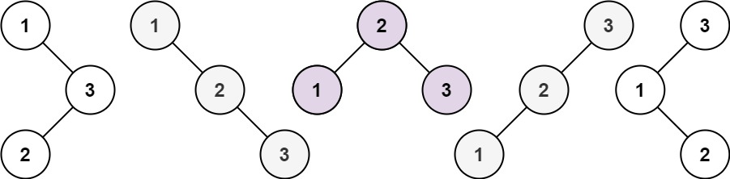

**Input:** n = 3

**Output:** 5

**Example 2:**

**Input:** n = 1

**Output:** 1

**Solution:**

class Solution {

public int numTrees(int n) {

int [] G = new int[n+1];

G[0] = G[1] = 1;

for(int i=2; i<=n; ++i) {

for(int j=1; j<=i; ++j) {

G[i] += G[j-1] * G[i-j];

}

}

return G[n];

}

}